2A Societies and Change – The USA between the wars

Task 5 Explanation – Cognitive Test 7.5%

- Write down the full dates for the following events unless otherwise stated.
  - America declares war on Germany (WW1) 6th April 1915
  - Monroe Doctrine (year) 1823
  - 19th Amendment was passed (year) 1920
  - The first 100 Days 9th March to 15th June 1933
  - America Declares war on Japan 8th December 1941
  - The first Talkie is shown (year) 1927 (6 marks)
- Rank the following events in chronological order

Fordney McCumber Tariff Act | 4
Washington conference | 3
US intervenes in Nicaragua | 6
Dawes Plan | 5
America Enters World War One | 1
Paris Peace Conference | 2
Manchurian Crisis | 7
Neutrality Acts | 8 | (4 marks)

- Who were the following people and what was their significance/position?
  - Henry Cabot Lodge: Republican Senator – opposed Wilson, League of Nations and signing Treaty of Versailles
  - Woodrow Wilson: President 1912-1920, 14 points, neutrality, convince people to want to sign Treaty and join league
  - Huey Long: Democrat Senator –‘share our wealth’ plan
  - Charles G Dawes: Chairman of Reparations committee
  - Eleanor Roosevelt: Presidents wife, just as popular as him
(5 marks)
- Key Quotes: Name the person who said the following
  - ‘the business of America is business’ Coolidge
  - ‘less government in business and more business in govt’ Warren G Harding
  - ‘Any customer can have a car painted any colour that he wants to as long as it is black’ Henry Ford (although not 100% that he actually said this)
  - ‘A chicken in every pot and two cars in every garage’. Hoover
  - ‘God gave us Ten Commandments and we broke them. Wilson gave us fourteen points, we shall see’ Clemenceau
  - ‘A strong and lasting peace’ Wilson
(6 marks)
- Explain the following terms:
  - Laissez Faire: Little govt involvement in business
  - Rugged Individualism: That everyone has the right to and ability to succeed by their own merits. (i.e. no matter your background, race, socio economic statues with hard work you too can become a millionaire/be successful)
  - Isolationism: Stay out of other countries affairs
  - Melting Pot: US society is a mixture of people from many different ethnic backgrounds
  - WASP: White Anglo Saxon Protestant
  - Flapper: Refers to the ‘new’ outrageous woman of the 1920’s. Short skirts, bob haircut, masculine, etc
  - Tin Lizzie: The Model T Ford
  - Speakeasies: Illegal bars where they would serve alcohol
  - Brainstrust : Roosevelt’s formidable group of advisors that he consulted to help pull US out of GD
  - Fireside Chats: When Roosevelt would talk over the radio to the people of America outlining what his govt was doing. People felt like he was talking directly to them. Kept him in touch in a time of despair.
(10 marks)
- Name the person concerned with the following events
  - Who was convicted in the Teapot Dome Scandal? Albert Fall
  - Who ordered the St Valentine’s Day Massacre? Al Capone
  - Who was convicted at the Monkey Trial? John Scopes
  - The American Banker who headed the relief committee to Germany in 1924.
  - The senator who opposed Wilson and the US joining the League. William Borah
(5 marks)
- List the presidents in chronological order that they served. Starting in 1914 and Finishing in 1941.
Wilson, Harding, Coolidge, Hoover, Roosevelt, Truman
(3 marks)
- For one president complete the following
  - President: __________________________
  - Party: ______________________________
  - Years served: _________________________
  - Two significant Achievements and/or failures
    - __________________________________________________
    - ___________________________________________________
(2 marks)
- What do the following acronyms stand for:
  - KKK: Ku Klux Klan
  - WPA: Works Progress Association
  - NRA: National Recovery Administration
  - AAA: Agricultural Adjustment Agency
(2 marks)
- Why did Congress reject the Treaty of Versailles?
Article 10 – Collective Security would drag US into others conflicts and only Congress had the power to declare war. Hence Article 10 contravened US constitution.
(2 marks)
- State two examples of intolerance in the USA in the 1920’s.
KKK, Sacco and Vanzetti, Scopes Monkey Trial
(2 marks)
- Name two products that were mass produced for the first time in the 1920’s.
  - cars
  - vacuum cleaner, fridges (1 mark)
- Outline how the Prohibition experiment affected American society.
Some possible answer are:
- Increase in crime - gangsters
- average people were breaking the law by visiting speakeasies and drinking alcohol
- corruption in police force
(3 marks)
- Why did the farmers not share in the general prosperity of the 1920’s?
machinery allowed over production and hence over supply so prices dropped.
European countries got themselves back on their feet after WW1 so that market dried up and there was less demand for US produce.
Competition from Canadian farmers.
(2 marks)
- List down three causes of the Great Depression.
- mass production/ overproduction
- over speculation
(3 marks)
- List down three examples of how America diverged from their Isolationist policy in the 1920’s.
- involvement in reparations meetings – Dawes Plan and Young Plan
- Washington Conference
- Return to Nicaragua
(3 marks)
- List down two things that America did during the 1930’s to maintain their isolationist policy.
- Neutrality Acts 1935-1936-1937
- Did not get involved in Manchurian Crisis
- Hawley Smoot Tariff Act.
(2 marks)
- Write a paragraph outlining the changes for women throughout the period of study.
- change in fashion, behaviour, morals
- entering workforce in larger numbers
- given the vote in 1920
- not all women supported the Flapper image and opposed the changes in women
(4 marks)
- Cartoon Analysis: Refer to the cartoon and answer the following questions.
  - Who are the three people in the cartoon?
    - Uncle Sam – sick
    - Roosevelt - Doctor
    - Congress – old nurse (1.5 marks)
  - What is the message of the cartoon? Roosevelt and his New Deal remedies were going to help heal a sick USA with the help of Congress. It is also referring to the fact that Roosevelt’s realises that if parts of the New Deal aren’t working they will have to change them.
(1.5 marks)
  - Choose two symbols in the cartoon and explain what they are showing.
    - Roosevelt is shown as a doctor and his doctors bag has New Deal Remedies written on which is referring to his plan to alleviate the Great Depression.
    - The Alphabet Agencies (New Deal) are shown as medicine bottles on the table. These Agencies are doing to alleviate the GD and hence heal a sick Uncle Sam (USA).
    - The nurse is representing Congress who was concerned that the New Deal was not working and has obviously relayed this concern to Roosevelt.
    - The Sick man is Uncle Sam (start and stripes pyjamas) who is used to represent the USA as a country.
(2 marks)
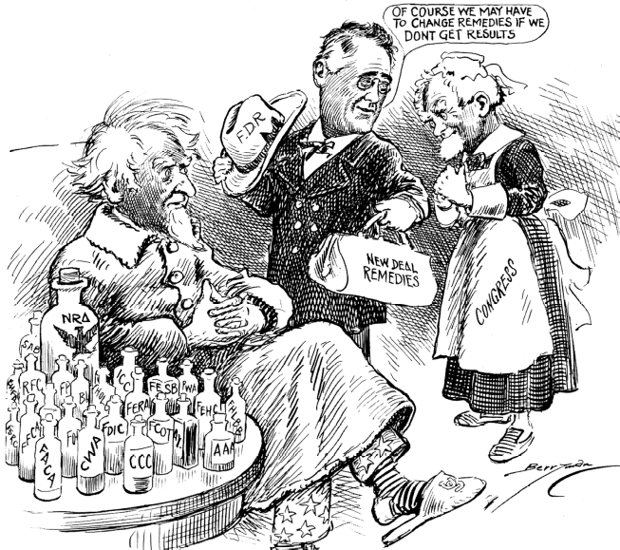

Total Marks: /70

Source: Clifford Berryman, Washington Star, 5 January, 1934, Library of Congress.

